**What is Academic Integrity at South Forsyth High School?**

International Baccalaureate (IB) programmes and South Forsyth High School encourage students to inquire and to think critically and creatively, and to present their thinking in a variety of ways. They should be able to make their thoughts and their learning visible and explicit, show how they have constructed their ideas, and demonstrate the views they have followed or rejected. This is essentially what scholarship and academic Integrity are: making knowledge, understanding and thinking transparent. Students need to understand how knowledge is constructed and, consequently, their own role in furthering knowledge construction and building understanding. An essential aspect of this is an understanding of the technical aspects of academic Integrity, of citing and referencing. Instruction on these aspects is presented in the Theory of Knowledge and Personal and Professional Skills courses as an introduction but is carried over into the various IB Subjects as well as the Extended Essay and Reflective Projects. Academic Integrity is an essential principle of the IB’s academic programmes that enhances the organization’s credibility and position as a leader in international education. As stated in the IB learner profile, all members of the IB community strive to be “principled”, acting with “integrity and Integrity, with a strong sense of fairness, justice and respect for the dignity of the individual, groups and communities”

Students in the South Forsyth High School IB Programs are given specific instruction in the Theory of Knowledge class and the Personal & Professional Skills class regarding scholasticism and how knowledge is acquired within various disciplines. They are shown the process to help them understand the reasons they should cite information used within their submitted works and are taught and encouraged to…

1. make clear which words, ideas, images and works are not your own (including maps, charts, musical compositions, movies, computer source codes and any other material).
2. Give credit for copied, adapted and paraphrased material.
3. When using text, make clear where the borrowed material starts and finishes with complete in-text citations.
4. All sources cited, including Artificial Intelligence, in the text must also be listed in the bibliography (or reference list/ list of works cited) and all sources listed in the bibliography (or reference list/list of works cited) must be cited in the text.

**What qualifies as Academic Misconduct?**

Academic misconduct is a behavior that results in, or may result in, the student or any other student gaining an unfair advantage (or a behavior that disadvantages other students) in one or more assessment components. Unfortunately, in every Diploma Programme examination session there are students who are investigated for alleged “academic misconduct”

IB Categories of “academic misconduct” recognized at South Forsyth High School for IB courses and procedures match those found in IB’s Academic Integrity Policy:

**Plagiarism** is defined as the representation, intentionally or unwittingly, of the ideas, words or work of another person without proper, clear and explicit acknowledgment. The use of translated materials, unless indicated and acknowledged, is also considered plagiarism.

**Collusion** is defined as supporting academic misconduct by another student, for example allowing one’s work to be copied or submitted for assessment by another.

**Misconduct** during an IB examination includes taking unauthorized material into an examination room, disruptive behaviour and communicating with others during the examination.

**Communication about the content of an examination** 24 hours before or after the examination with others outside their school community is also considered a breach to IB regulations.

**Duplication** of work is defined as the presentation of the same work for different assessment components and/or Diploma Programme requirements.

Additionally, South Forsyth has taken the concept of Academic Integrity and applied it across our school’s curriculum with the inclusion and adoption of an Honor Code Process, as well as instruction to both staff, students, and our community regarding expectations of behavior with the War Eagle Way.

**Application – The Honor Code**

South Forsyth High School has adopted an Honor Code Process. This process goes through an annual review involving administration and teaching staff with input from parents and students. When a student is accused of Academic Misconduct, they are referred to the administration who then follows the Honor Code Process. The aim is to educate the student on expectations and reasons for academic Integrity rather than emphasizing consequences, though at higher tiers consequences are part of the process. Every IB student attends an academic integrity workshop each year in the Fall semester. We discuss the reasons for Academic Integrity, the types and pitfalls, the consequences and reporting procedures for our school and program, and the consequences if it is discovered by IB post submission.

Additionally, for any misconduct involving IB assessments, the situation is handled at the school level first and foremost. If misconduct occurs and involves external assessments by IBO or is not discovered until after the submission to IBO has occurred, the IB DP and CP Coordinators may be called upon to address specific misconduct steps to IBO and submit the necessary documentation as Malpractice per the requirements specified in IB’s Academic Integrity pieces.

This section contains the IB penalty matrices detailing infringements by the student and the level of penalty which may be applied by the IB. In the event of an unprecedented and/or extraordinary incident please see "Good practice for investigating academic misconduct."

**Written and oral coursework and examinations**

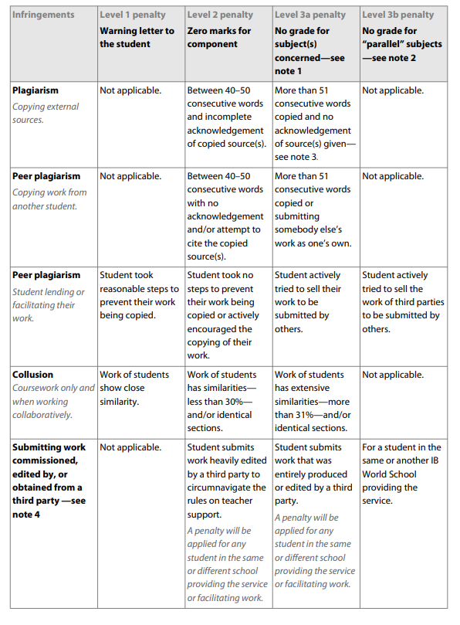

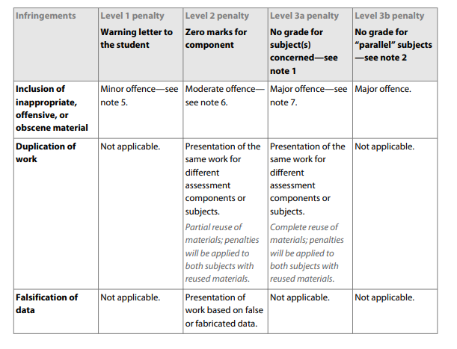

**Conduct during an examination**

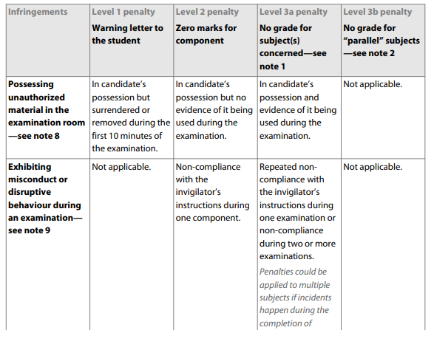

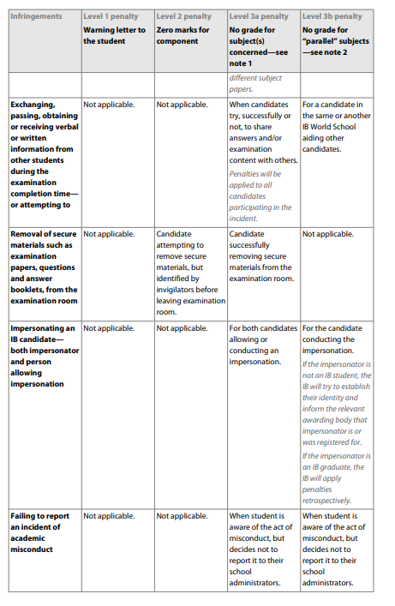

**Conduct that threatens the integrity of the examination**

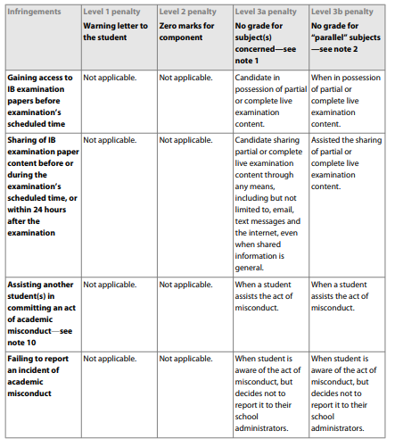

**Interfering with an academic misconduct investigation**

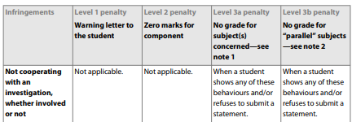

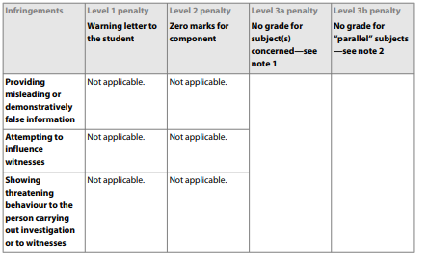

Explanatory notes

1. Level 3a penalty. This depends on the seriousness of the incident; the penalty can be extended to several or all subjects of the session.
2. Level 3b penalty will be applied to IB students involved in a form of misconduct that benefits another student rather than themselves.
3. As approved by the Final Award Committee in November 2013, the level 2 penalty is not applicable for extended essays (EEs). Due to the nature of the subject, only one assessment component (the level 2 and level 3a penalties) have the same outcome on the candidate’s final result, the non-award of diploma. Therefore, plagiarism cases in EEs will only be considered when a considerable amount (more than 100) of consecutive words lacks proper reference.
4. Submitting work commissioned, edited by, or obtained from a third party. This list includes, but is not restricted to: Appendix 2: Student academic misconduct 36 Academic integrity

• friends, family members, or other students in the same or different school, college or university

• private tutors

• essay writing or copy-editing services

• pre-written essay banks

• file-sharing sites.

1. Minor offences may include but are not restricted to:

• conducting research without permission of the participants

• including offensive or obscene comments or graphic materials in any assessment component

• inclusion of materials with excessive or gratuitous violence or explicit sexual content or activity that could be considered or perceived offensive by others.

1. Moderate offences may include but are not restricted to:

• conducting field experiments or investigations that inflict pain or risks the well-being or survival of live organisms

• conducting research or fieldwork that damages the environment

• including offensive or obscene comments or graphic materials in any assessment component.

1. Major offences may include but are not restricted to:

• producing any work that shows disrespect of personal, political and/or spiritual values, and/or contain offensive remarks about race, gender, or religious beliefs

• falsification or fabrication of data in producing any work

• inclusion of materials with excessive or gratuitous violence or explicit sexual content or activity that could be considered or perceived offensive by others.

1. Unauthorized materials or items may include but are not restricted to:

• mobile or cellular phones

• notes

• study guides

• own rough or scratch paper

• non-permitted dictionaries

• other prohibited electronic devices such as smartwatches or smartglasses.

1. Misconduct during examinations may include but are not restricted to:

• failing to abide by invigilator instructions

• disruptive behaviour

• attempting to remove examination materials from the examination room

• leaving the examination room without permission.

1. Assisting other student(s) in committing an act of misconduct may include but are not restricted to:

• facilitating information to other candidates during the completion time of the examination

• distributing live examination content before, during or after the scheduled time of that examination through any means